CSE211 Web Programming, Fall Semester 24/25

Assignment #1: Websites conceptual Design and mock-u

ID: 222100264, Name: Alhassan Muhamed Abdulmonem Muhamed

14- a. To have 100,000 clients.

b. Movies, Series, Search bar, Sign in, Sign up, English movies, Arabic movies, English series, Arabic series

c. **Home** **Page** (logo, website name, navigation (movies, series, search bar, sign in), picture & name of random movies

**Movies** (picture & name for only movies)

**Series** (picture & name for only series)

**Search** **bar**

**Sign** **In** (username, password, forgot password, sign in, sign up)

**Sign** **Up** (First name, Last name, Email address, password, confirm password)

**English** **movies** (Action Movies (picture & name), Comedy movies (picture & name)

**Arabic** **movies** (Action Movies (picture & name), Comedy movies (picture & name)

**English** **series** (Action Movies (picture & name), Comedy movies (picture & name)

**Arabic** **series** (Action series (picture & name), Comedy series (picture & name)

d. Feature Requests: Users can submit suggestions for new features or improvements to the platform.

e.

f. **Home Page**

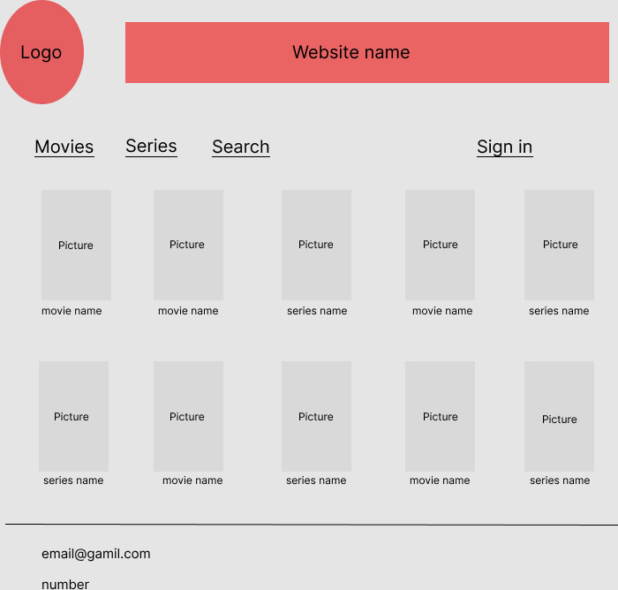

**Movies**

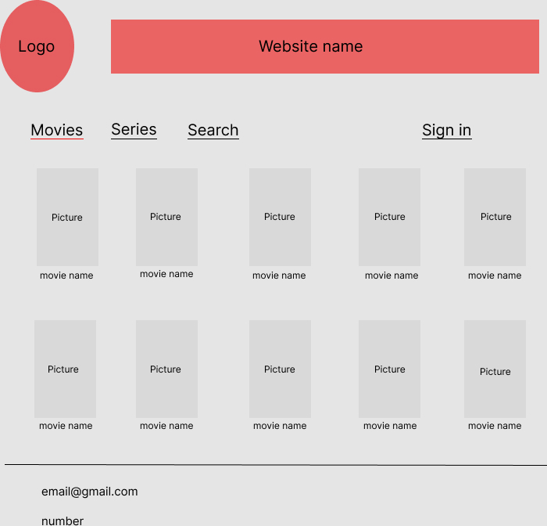

Series

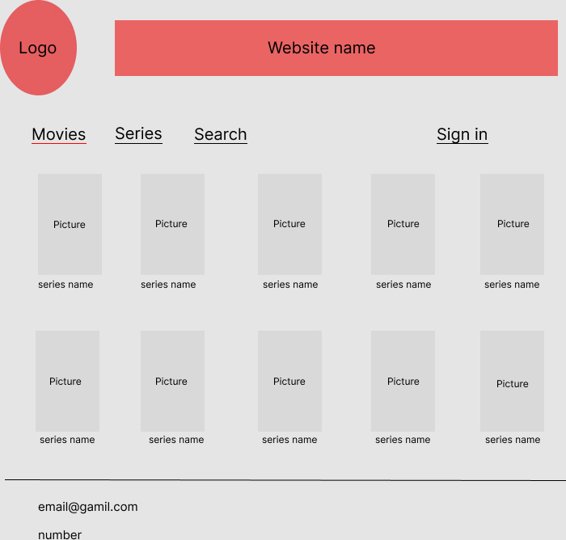

Search bar

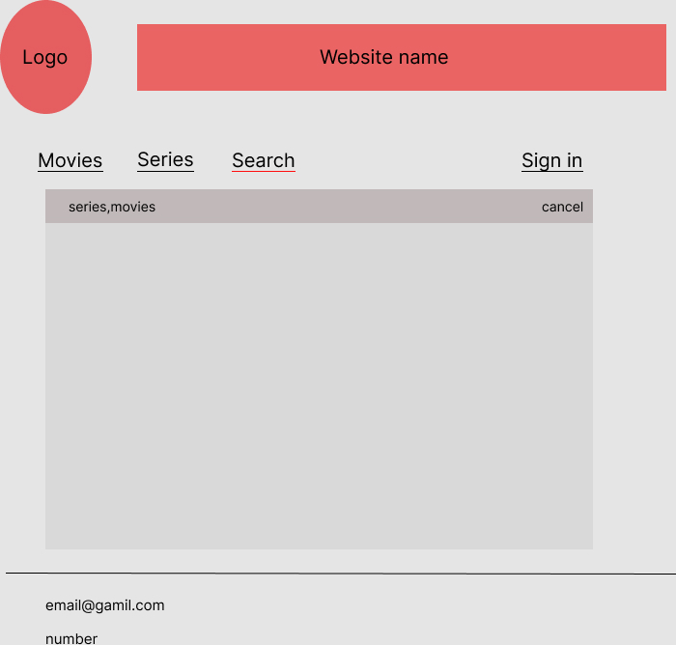

**English Movies**

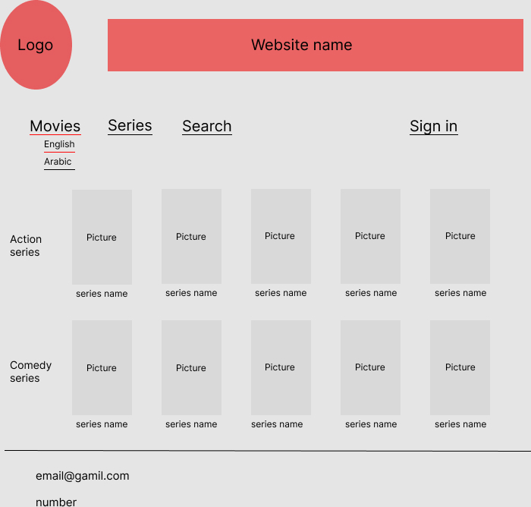

**Arabic Movies**

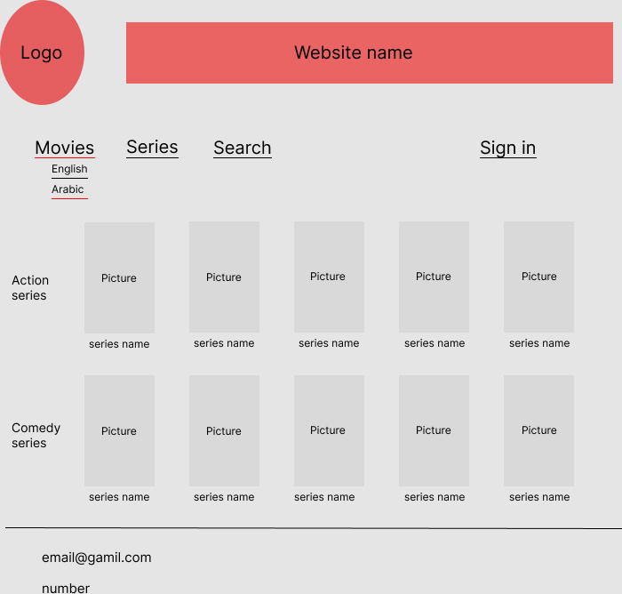

**English Series**

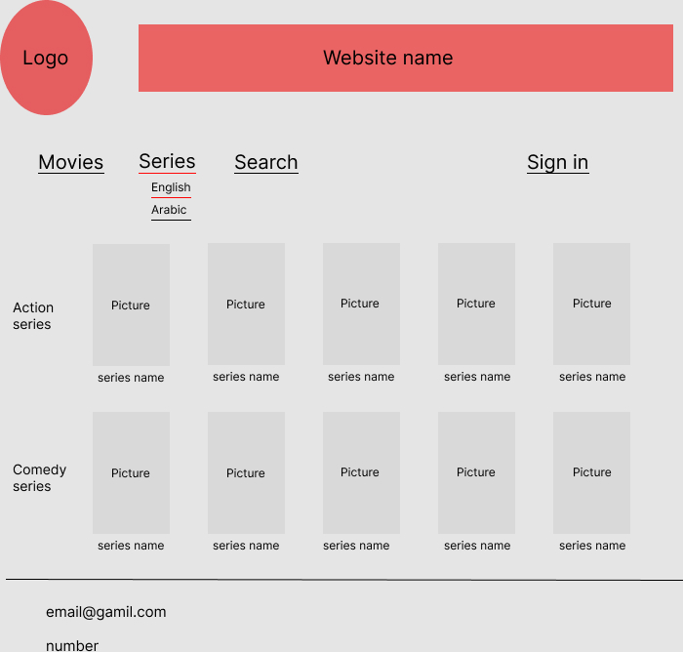

**Arabic Series**

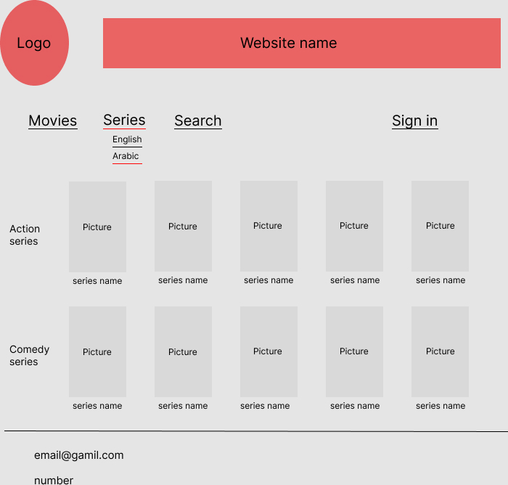

**Sign in**

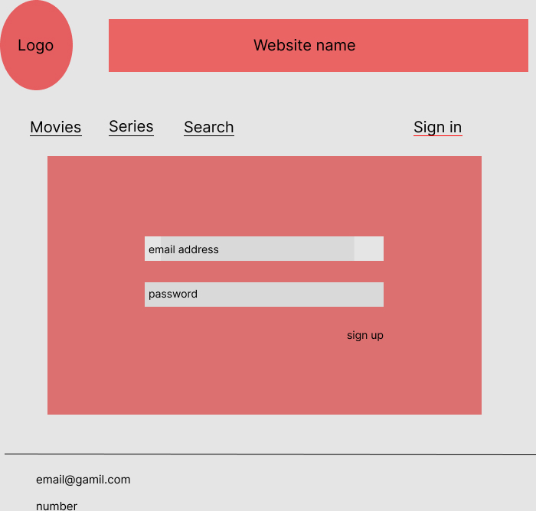

**Sign up**

